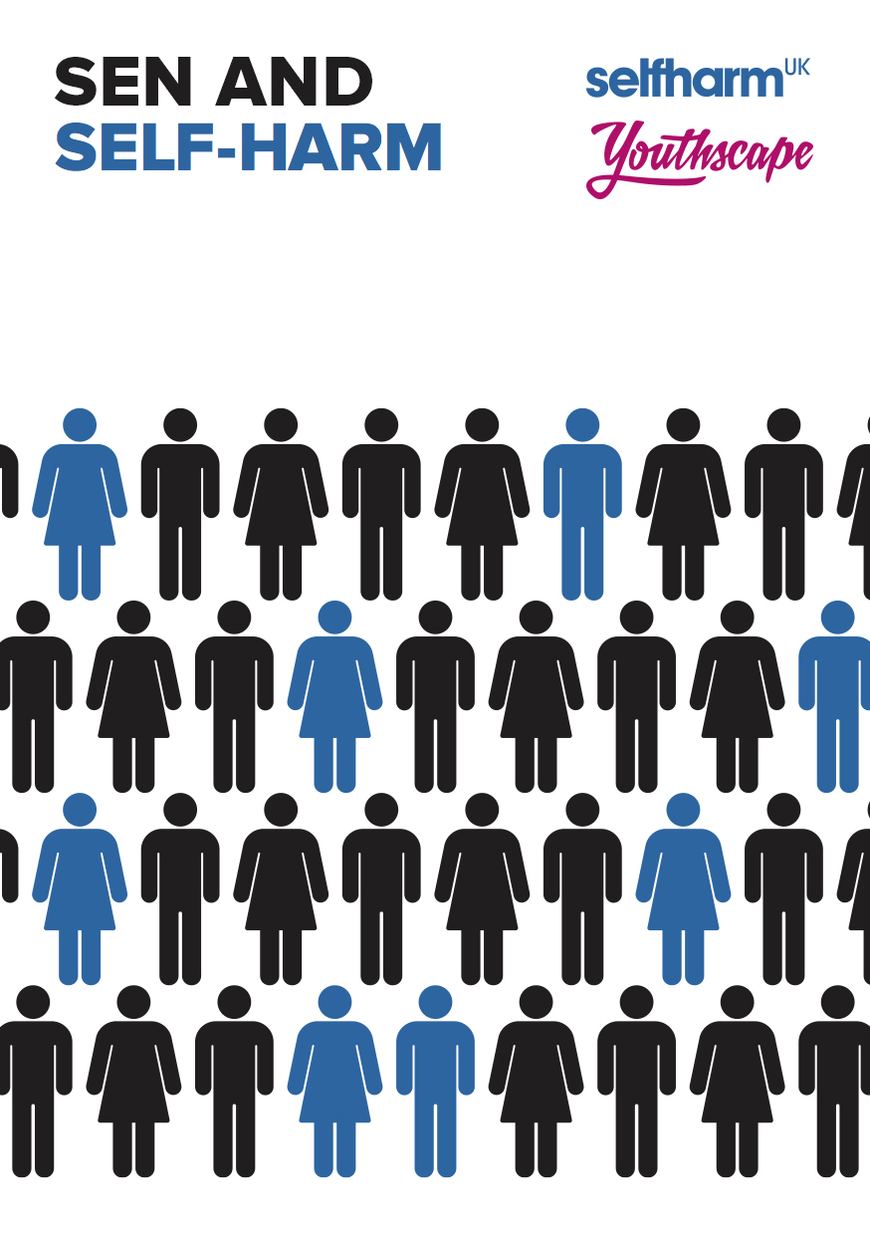
We hope by reading this E-guide you will gain some insight, help and support as to why your child with additional needs may have begun harming. There are many contributing factors as to why young people with Special Educational Needs (SEN) begin to self-harm. Complex Emotional, Social, Behavioural and Communication difficulties will often cause young people to harm for different reasons to others.

No two-young people with additional needs are the same, it can hugely affect their daily lives and their emotional ability to manage in many ways. This makes young people that come under these umbrellas difficult to parent and manage. In this resource, we want to help you with some background information, some tools and some questions to begin to think through what your child needs and feel more able to take control, verbalise feelings and, ultimately, be safer.

Here is a list of possible reasons for your child’s self-harming behaviour. It may well be that there are a few contributing factors:

- Difficult in articulating feelings - Their additional needs may mean they struggle to understand and articulate feelings appropriately. This inner struggle to find the words they want to speak, (or are unable to speak if non-verbal) heightens the possibility of harming behaviour. Some may explode by taking out their feelings of frustration, anger or sadness; others implode – they take it out on themselves.

- Avoidance – To escape a certain situation that the person feels unable to control or is uncomfortable with. It may be to avoid the emotion linked to a certain place/person e.g. at school, in a certain lesson, before a meal or visiting a certain person. These things may heighten anxiety and lead to harming behaviours to either physically escape a situation (by having to be removed) or emotionally escaping (by ‘letting out’ pain by self-harming;

- Attention – Unmet emotional needs or social needs. Is it possible there are feelings that aren’t being addressed; is the young person isolated, feeling alone or feeling overwhelmed in a crowd? Do they get their emotional and social needs met by family/friends/siblings? Children with additional needs are often isolated through preference, or by the ignorance of others. Even those who prefer to withdraw are often angry at themselves for not being able to socialise easily.

- Frustration – Frustration can bring a lot of painful feelings in most of us, when we are unable to communicate how we are feeling, it can lead us to many types of behaviours. Young people with additional needs can feel frustrated a lot of the time, especially around communication. Simple things like feeling unable to understand a situation/person/task can lead to feelings of being out of control.

- Bio chemical – Those on the Autistic spectrum are shown to have lower levels of endorphins, so self-harm may be used to self soothe as it releases endorphins. Does your child have regular blood tests to check vitamin levels, medication effectiveness etc? If your child is on medication – are you aware if their mood has lowered as a result?

- Repetitive behaviours - The repetitive nature of your child will depend on their diagnosis, there is a high correlation between ASD and OCD. This joint diagnosis may culminate into long term self-harm as the self-harm is only a small part of the compulsory behaviour, it is cyclic. The ritual of preparing to self-harm is as much of the process as the act of harming for many ASD teenagers.

Picking is often the most over looked repetitive behaviour of self-harm – picking scratches (self-made or not), picking spots, fingers, pulling hair, picking noses until they bleed; it may be due to lack of stimulation of mind and hands.

- Sensory stimulation: seekers and avoiders – A sensory profile may well have been done with your child before their diagnosis of their needs. For some this means they love noise, lights, bouncing around, climbing, water play and driving with the windows down. The sensory avoiders are those for whom noise is too loud, smell too strong, touching is horrendous, wearing certain fabrics is too uncomfortable and crowds all too much: avoiders find life very hard and exhausting.

Sensory seekers may harm themselves to seek out pain and sensory stimulation, where as those who seek to avoid sensory interactions may use self-harm as a coping strategy to manage their overwhelming feelings and seek relief from the sensory overload. Either way, both are at risk from increasing their harming behaviour to soothe themselves.

Possible strategies:

Look and observe repetitive behaviours to break a pattern before it comes to be a compulsory behaviour. It may help to keep a parental journal or diary around this.

Rule out any medical or dental causes of pain in the body – use a body outline for the person to mark pain if possible. Pain scales may also be helpful.

Include sensory breaks if over stimulated/give sensory involvement if under stimulated.

Increase structure and routine at times of change/loss/bereavement to give stability to reduce anxiety. Timetables, including visual timetables may help. If a young person is feeling in control, the risk of harming decreases along with their anxiety. Social stories are a brilliant tool to help prepare a young person for a particular event, for example a hospital visit. The story is told in the first person and includes sensory details in order to help a young person understand how it might affect them. You can find more information here:

http://www.autism.org.uk/about/strategies/social-stories-comic-strips.aspx

Using communication tools maybe be helpful for some young people, but this will depend on their communication abilities. Young people with Asperger’s may be able to communicate on their specialist subject extremely articulately but unable to express feelings and thoughts – ensure they are catered for as well as those with limited communication. Picture Exchange Communication System (PECS) for those with very limited verbal communication is an excellent aid; social stories can also enable young people to identify and learn how to develop their communication. You can purchase PECS here:

https://www.amazon.co.uk/Picture-Exchange-Communication-Instructions-Behaviour-x/dp/B008OGE8JQ/ref=pd_lpo_sbs_14_img_1?_encoding=UTF8&psc=1&refRID=QQ874AV70R19YMFAS6BE

Discuss medication with your GP, what is the young person currently taking, could it be contributing to any mood swings or even adding to depressive thoughts and behaviours?

Liaise with other families/social services/agencies to build comprehensive strategies. Most parents of children with additional needs are incredibly self-reliant, resourceful and creative; they fight hard for what they know their child needs. If your child is self-harming ensure everyone involved with your child knows about it, work together to ascertain a bigger picture of behaviours so you are all aware of their trigger points.

The following is a list of other strategies that you may find helpful:

Feelings | Strategies
Anger and Frustration | - Do some form of exercise such as going for a run or going swimming  - Punch pillows  - Shout  - Jump up and down  - Squeeze a stress ball  - Rip up paper  - Tidy your bedroom  - Do some breathing exercises  - Listen to loud music  - Curl and uncurl your toes  - Use a recipe to cook or bake something  - Gently stroke a pet or a soft cuddly toy  - Do some angry art such as graffiti  - Throw stones into the sea  - On paper, scribble down how you feel using a big black marker, screw it up and throw it away  - Squeeze ice cubes  - Roll up a newspaper and hit it against a door frame
Sadness and Fear | - Wrap yourself up in a blanket, afterwards, have a warm shower or bath  - Allow yourself to cry, then sit and watch a film with a positive and upbeat story  - Curl up and go to sleep, then go for a walk somewhere quiet  - Listen to calming music, then do some breathing exercises  - Talk to someone either face-to-face or on the phone about why you are sad, then ask them to  give you a hug or day something nice about you  - Write a list of things you’re thankful for (these could be as big as the air you breathe,  or as small as your favourite chocolate bar for example)  - Start a journal or scrapbook containing how you feel as well as images that inspire  you or capture how you feel (this could include inspirational quotes, song lyrics,  typography or photos)  - Watch videos online that will make you laugh
Stressed out or not in control | - Write down how you are feeling and keep a thoughts journal  - Write down a list of things that make you happy and go and do one of them  - Make a mess and then tidy it up  - Break something and put it back together  - Do some breathing exercises  - Pop bubble wrap  - Lose yourself in an inspiring film  - Draw, colour or paint something to express how you are feeling  - Read a book or magazine  - Squeeze a stress ball or play with Play-Doh or clay  - Use a recipe to cook or bake something  - Learning a new skill can be a great distraction (Origami, knitting for example)  - Think about volunteering, for example with animals. How can you make something  good happen?
Shame, Self-hatred, wanting to punish yourself | - Read something good someone has written about you  - Do something someone else will be appreciative of  - Talk to someone that cares about you  - Do some form of exercise such as going for a run or going swimming  - Think of a safe place where you are happiest, close your eyes and picture yourself  there  - Look through some old photographs that bring back happy memories  - Draw, colour or paint something to express how you are feeling  - Use a recipe to cook or bake something  - Do some breathing exercises  - Consider volunteering somewhere as a way to increase your self-esteem. For  example with vulnerable people

Most of all: you are doing an excellent job! It might not feel like it, but you are.
The list of Special Education Needs is incredibly long and whilst we will not be able to cover all of them this guide includes some specific details on Autism including Asperger Syndrome, Attention Deficit Hyperactivity Disorder (ADHD), Down Syndrome, Dyspraxia and Tourette’s Syndrome.

Autism including Asperger Syndrome:

“Autism is a lifelong, developmental disability that affects how a person communicates with and relates to other people, and how they experience the world around them.” (National Autistic Society)

Any teenager finds life a struggle especially around times of transition and change, for those with Autism this change can be even more difficult;

A recent report has shown that:

- 50% of people on the Autistic Spectrum will have self-harmed;

- 1 in 4 will be currently have an issue with it

- The difference between ‘toddler tantrums’ and self-injury is rarely noted before age
3, but begins at 12 months as a behaviour that a child finds self-soothing. IE. A pre-toddler may learn a form of behaviour that helps them relax, whether that be singing to themselves (a positive self-soothing behaviour) or rubbing themselves on the carpet until they get carpet burns (negative due to the physical damage). Children with sensory needs, may find the more negative self-soothing behaviours help to calm them better. These will often become a habit from 3 years old.

Certain conditions linked to autism such as ADHD, tourettes, global delay and OCD heighten the likelihood of self-harming. For example, a combination of autism (struggling to communicate feelings), combined with OCD (repetitive behaviours) can result in prolific self-harming.

In our experience teenagers with Autism may quickly form habits that can lead to obsessional behaviours. Picking one’s fingers until they bleed is a common occurrence due to the need to keep fingers busy, to reduce sensory stimulation, or due to anxious habit and/or fear of germs. Those habits can quickly develop into obsessional behaviours. If you can find something to occupy your child’s hands and brain this may help. Fidget cubes can be excellent for this:

http://www.thetoyshop.com/stress-toys/Fidget-Cube-Original-Anti-Stress-Toy---Black/p/531638_black?gclid=CjwKEAjw2qzHBRChloWxgoXDpyASJAB01Io0ZoYK-03BUKyVBW-O_cSC0ljCadcTkxZkxY85R1JomBoCCLfw_wcB

However the pain element is also a big reason that causes young people with Autism to harm. If this is the case, fiddling with an object may not fulfil that need and they may find another way to achieve this.

ADHD:

“Attention deficit hyperactivity disorder (ADHD) is a group of behavioural symptoms that include inattentiveness, hyperactivity and impulsiveness.” (NHS)

Psychologists link young people with ADHD suffering with self-harm to the impulsivity of ADHD and as with Autism there is a strong link between the physical pain and the release of over bearing sensory issues that the young person is struggling with.

It is common in young people with ADHD not to have a “normal” pain range, sometimes it can be exceptionally high and other times exceptionally low, there is little research into exactly why young people who suffer with ADHD begin to harm, but there have been reports into the links between ADHD and suicide. This is why it is so important that all help and support is offered to your child and why a diagnosis can help with getting this support.

If your child is harming remember to keep any medication, prescribed or shop bought, out of reach and sight.

ADHD is a complex and often very misunderstood condition and self-harm can make it even harder to understand. Try and help them to communicate in a variety of ways until you find what works best for them. A great resource for young people with Autism and ADHD are PECS cards which stand for Picture Exchange Communication System.

Having pictures around the house as an alternative way of communicating may help your child to come to you when they are struggling with lack of communication or sensory overload.

Down Syndrome:

“Down's syndrome, also known as Down syndrome, is a genetic condition that typically causes some level of learning disability and characteristic physical features.” (NHS)

Young people with Down Syndrome can show harmful behaviours that may look different from stereotypical forms of self-harm, young people with down syndrome may at times get frustrated around communication differences and this can lead to head banging, wall punching and hair pulling. These things are self-harm but are occurring out of frustration rather than deep rooted emotional pain.

Low self-esteem is often felt by young people with Down. Issues around low self-worth, frustration and young people feeling scape-goateed in wider society can sometimes mean they begin to self-harm. This may be something that you need to be prepared to investigate and communicate with your child about. Be sure to use tools that work for your child, SelfharmUK have some excellent playing cards that will help your child to begin to talk to you about how they are feeling. Depending on your child’s level of development you may have to help them with some of the questions, but they may help as a starting point. You can purchase them here:

https://www.youthscape.co.uk/store/product/talking-about-emotions-playing-cards

Of course, low self-esteem isn’t just tough for young people with Down Syndrome, all young people can suffer with this, but there is lots of research between young people with SEN and self-esteem, The Down Syndrome Society have some excellent information on this and it can be found here:

https://www.downs-syndrome.org.uk/?s=self-esteem

It can also be more likely that young people with additional needs will be bullied and this can mean they might turn to self-harm. It is so important that you keep in touch with your child’s school and especially their Special Educational Needs Coordinator (SENCO).

Dyspraxia:

“Dyspraxia is a form of developmental coordination disorder (DCD). It affects fine and/or gross motor skills in children and adults. It may also affect speech. Dyspraxia is a lifelong condition, and is distinct from other motor disorders such as cerebral palsy, it occurs across the range of intellectual abilities. Individuals may vary in how their difficulties present: these may change over time depending on environmental demands and life experiences.” (Dyspraxia Foundation)

Young people with dyspraxia can often suffer with low self-esteem and this can become very difficult for them to manage, young people with dyspraxia will also often struggle with organisational tasks and motor skills, this can mean that in the same vein that young people with Autism and Asperger’s become frustrated around communication, the same can be said for Dyspraxia, young people with this diagnosis will often turn to forms of self-harm to manage frustrations and due to extremely low self-esteem.

Tourette’s:

“Tourette’s syndrome is a neurological condition (affecting the brain and nervous system), characterised by a combination of involuntary noises and movements called tics.” (NHS Website)

There are huge links between young people with Tourette’s and self-harm, and many articles link to the same impulsiveness that is seen in those with ADHD. Young people with Tourette’s can also feel socially ostracised due to their involuntary noises and movements. This can lead to isolation and depression and it is vitally important that you try to help your child try and combat and tackle these social norms. There are support groups and often summer camps that are run for young people with Tourette’s and this can be a good way to help your child socialise. Your local Youth Service would be a good place to go to get some access and support around groups.

Self-Care:

Caring for yourself when parenting or caring for a child with additional needs usually comes way down the list of priorities. We know we should look after ourselves, but often the reality of dealing with the emotional, educational and mental health demands of our children far outweighs our own demands.
Self-care is about giving yourself permission to take ‘time out’ for no reason other than you need a rest! Whether it being seeing friends, walking alone, taking yourself to the cinema – whatever you need to do to regularly look after you.

If you are finding life a little too much, perhaps a trip to your GP to discuss your own mental health might be helpful too as a starting place.

In all these instances, don’t forget the huge amount of advice and support that your GP and Local Authority can offer you, reach out to like-minded people with the same concerns and feelings of uncertainty and don’t be afraid to ask for help where needed.

